**INDUSTRIAL TRAINING REPORT**

**Blue Prism**

Submitted in partial fulfillment of requirement of the Degree of

**BACHELOR OF TECHNOLOGY in COMPUTER SCIENCE & ENGINEERING**



SUBMITTED BY SUBMITTED TO

**Name: Sourabh Thakur Prof. Sanket Gupta**

**E. No: EN19CS301382 & Prof. Latika Jindal**

**Department of Computer Science & Engineering Faculty of Engineering**

**MEDI-CAPS UNIVERSITY, INDORE- 453331**

**Aug-Dec 22**

### Report Approval

The Industrial Training Report entitled **“Blue Prism”** is hereby approved as a creditable study of an engineering subject carried out and presented in a manner satisfactory to warrant its acceptance as prerequisite for the Degree for which it has been submitted.

It is to be understood that by this approval the undersigned do not endorse or approved any statement made, opinion expressed, or conclusion drawn there in; but approve the “Industrial Training Report” only for the purpose for which it has been submitted.

Internal Examiner Name:

Designation

Affiliation

External Examiner Name:

Designation

Affiliation

**Declaration**

### I hereby declare that the Online Internship entitled “Blue Prism” submitted in partial fulfillment for the award of the degree of Bachelor of Technology in ‘Computer Science & Engineering’ completed under the supervision of Prof. Sanket Gupta and Prof. Latika Jindal, Department of Computer Science, Medi-Caps University In-House Industrial Training from 18-07-2022 to 12-08-2022.

### Further, I declare that the content of this Industrial Training, in full or in parts, have neither been taken from any other source nor have been submitted to any other Institute or University for the award of any degree or diploma.

___________ Signature

### Certificate

### This is to certify that Mr. Sourabh Thakur has completed Industrial Training during the period from 18-07-22 to 12-08-22 in our Organization Medi-Caps University as a Partial Fulfillment of Degree of Bachelor of Technology in Computer Science & Engineering He was trained in the field of Blue Prism.

Prof. Sanket Gupta

Prof. Latika Jindal

Dr. Pramod S. Nair Head of the Department

Computer Science & Engineering Medi-Caps University, Indore

### Acknowledgements

I would like to express my deepest gratitude to Honorable Chancellor, **Shri R C Mittal,** who has provided me with every facility to successfully carry out this Industrial Training, and my profound indebtedness to **Prof. (Dr.) Dilip Kumar Patnaik,** Vice Chancellor, Medi-Caps University, whose unfailing support and enthusiasm has always boosted up my morale. I also thank **Dr. Suresh Jain,** Dean, Faculty of Engineering, Medi-Caps University, for giving me a chance to work on this Industrial Training. I would also like to thank my Head of the Department **Prof. (Dr.) Pramod S. Nair** for his continuous encouragement for betterment of the Industrial Training.

I express my heartfelt gratitude to my **Instructor and Guide** Prof. Prof. **Sanket Gupta and Prof. Latika Jindal,** **Department of Computer Science, Medi-Caps University**, without whose continuous help and support, this Industrial Training would ever have reached to the completion.

It is their help and support, due to which we became able to complete the design and technical report.

Without their support this report would not have been possible.

Name: Sourabh Thakur

E.No: EN19CS301382

B.Tech. IV Year

Department of Computer Science & Engineering

Faculty of Engineering

Medi-Caps University, Indore

**Table of Contents**

1. Introduction

Blue Prism

Features of Blue Prism

The Architecture of Blue Prism

Components of Blue Prism

1. Tools & Technology Used
2. Discussion

Analysis and Observations

Applications of Blue Prism

Benefits of Blue Prism

Companies Using Blue Prism

1. Conclusion
2. References

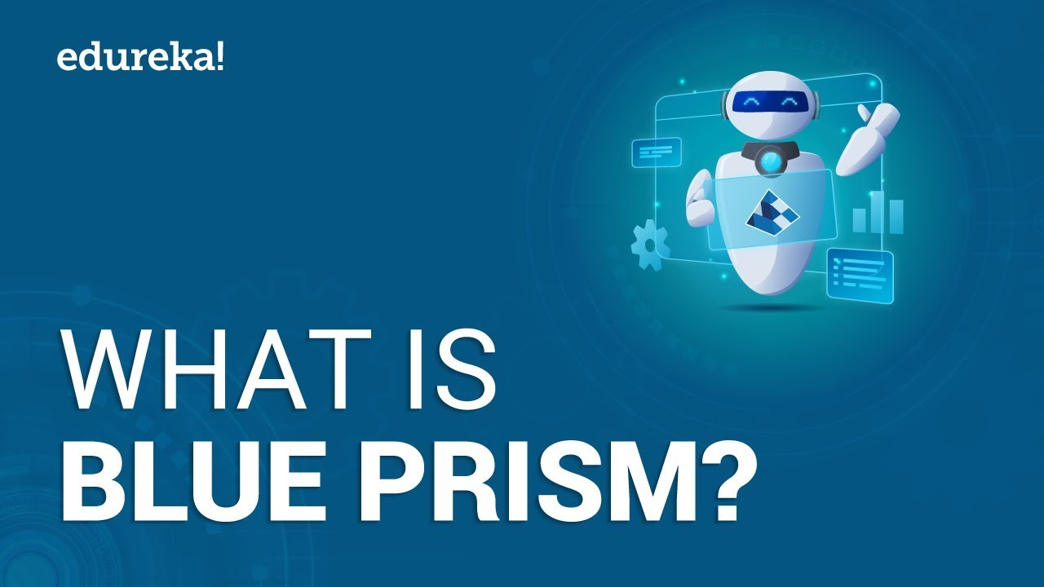

1. **Introduction**

Blue Prism is a global pioneer in intelligent enterprise automation, improving how employees work. The Blue Prism helps organizations enhance operational efficiency and agility by making it simple for individuals to automate tasks. If you're interested in knowing what Blue Prism is then you're at the right place. Read this tutorial on “What Is Blue Prism” to get a complete understanding of not just about Blue Prism but how you can gain knowledge in it and make a career in the [automation](https://www.simplilearn.com/automation-anywhere-from-daily-life-to-rpa-software-article) industry.

## Blue Prism

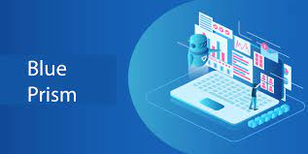

* Blue Prism is a software company that develops industry [robotic process automation (RPA) software](https://www.simplilearn.com/tutorials/rpa-tutorial/what-is-rpa) that enables businesses to automate complicated, end-to-end procedures.
* Blue Prism created the Virtual Workforce Platform concept and is working on a robust, highly scalable, secure, and dependable enterprise Robotic Process Automation platform.
* Blue Prism's software complements traditional IT solutions by utilising an agile virtual workforce that adheres to rule-based business processes and interacts with systems similar to users.
* Blue Prism's RPA software solution automates processes that humans would otherwise perform manually or through extensive customization of existing IT systems, resulting in a greater level of automation with significantly less investment and faster deployment.

## Features of Blue Prism

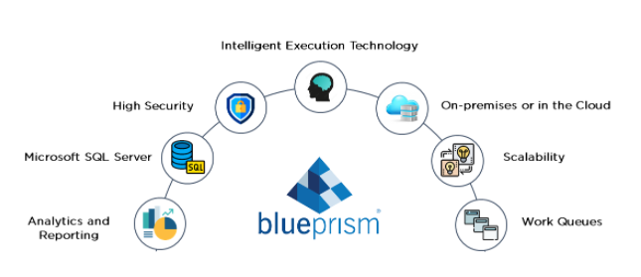

### Provides Intelligent Execution Technology

Organizations can teach the autonomous engine to run on process priorities, feed it with work, and then leave it to run autonomously, responding to systems, business scenarios, and preferences changes. Robots, like humans, can perform jobs based on SLA, volume, and priority and dynamically alter and change robot allocation without human intervention.

### Compatible With a Variety of Platforms

They built Blue Prism on the[Microsoft.NET Framework.](https://www.simplilearn.com/tutorials/asp-dot-net-tutorial/what-is-asp-dot-net) It is technologically adaptable, functioning across several platforms and technologies, such as the mainframe, windows app, WPF app, [Java,](https://www.simplilearn.com/best-java-programs-article) SAP, Exchange, custom apps, Citrix, thick client, thin client, web services, and so on.

### High Security

A software robot securely connects to an application and manipulates the presentation layer in the same way that a human would, but in a controlled, non-invasive environment, assuring that it never damages the program's integrity.

### On-Premises or Cloud-Based

On-premises or hybrid enterprise deployment, with [public or private cloud](https://www.simplilearn.com/difference-between-private-and-public-cloud-article) provisioning. The robots are operational, and they can perform any operation defined in Blue Prism on any number of robots in the Virtual Workforce.

### Scalability

Blue Prism is object-oriented, which allows for rapid scalability through the use of reusable components and libraries.

### Reporting and Analytics

By capturing each step, it is possible to generate high-quality data that can be utilized to provide relevant BI and MI reporting and inline process statistics, and real-time operational insights.

### Work Queues

Work Queues is a queue-centric approach for dynamically controlling the number of resources, or robots, operating against a given queue at any given time, allowing for maximum flexibility in adjusting the number of resources assigned to collaboratively work items in the queue based on business demands.

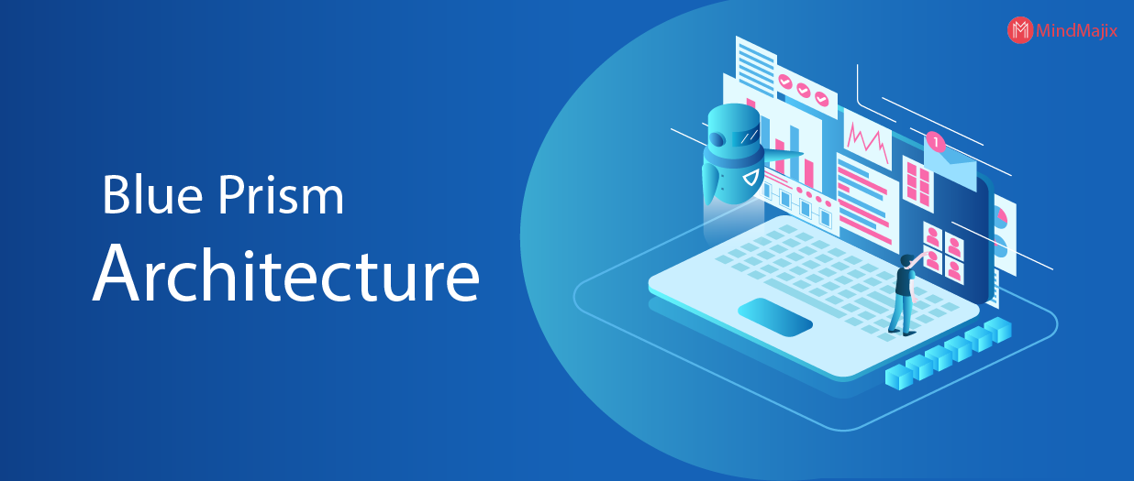

## The Architecture of Blue Prism

After beyond the fundamentals of what is Blue Prism to getting a deeper understanding of the Blue Prism technology. The Blue Prism technology is backed by a comprehensive methodology for rapid business process development, deployment, and operational support, allowing for a whole business process cycle to be completed within the same environment.

### Monitoring and Referrals

Technical service monitoring and business-owned referral management for work items requiring additional, manual steps.

### Operational Methodology

It is a comprehensive framework for implementing Blue Prism methodologies, including analysis, design, development, and implementation.

### IT Governance

The principles that underpin "best practice" in process selection change management and release procedures.

### Operational Configuration

Ownership of the Blue Prism product for operational configuration, testing, and execution.

### Roles and Responsibilities

Within the methodology, there are clear, devolved roles to manage and implement the many aspects of ongoing agility.

### Security

Functions of security products, infrastructure, and methodology that provide a secure and compliant implementation.

### Support and Hosting

A robust, scalable infrastructure that allows for rapid deployment and expansion based on business requirements.

## Components of Blue Prism

To get a complete understanding of what is Blue Prism, it is really important to understand the components that make the Blue Prism architecture

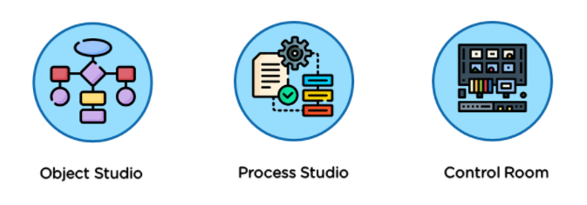

### Object Studio

Object Studio allows business users or IT professionals to construct reusable Blue Prism Objects as the building blocks for the business process by modeling current applications and training Blue Prism as a robotic user.

Object Studio is the design canvas on which you program the Blue Prism robot to conduct the fundamental system activities that serve as the foundation of processes. The presentation layer, which provides a library of elements to operate, quickly models and validates the target desktop application.

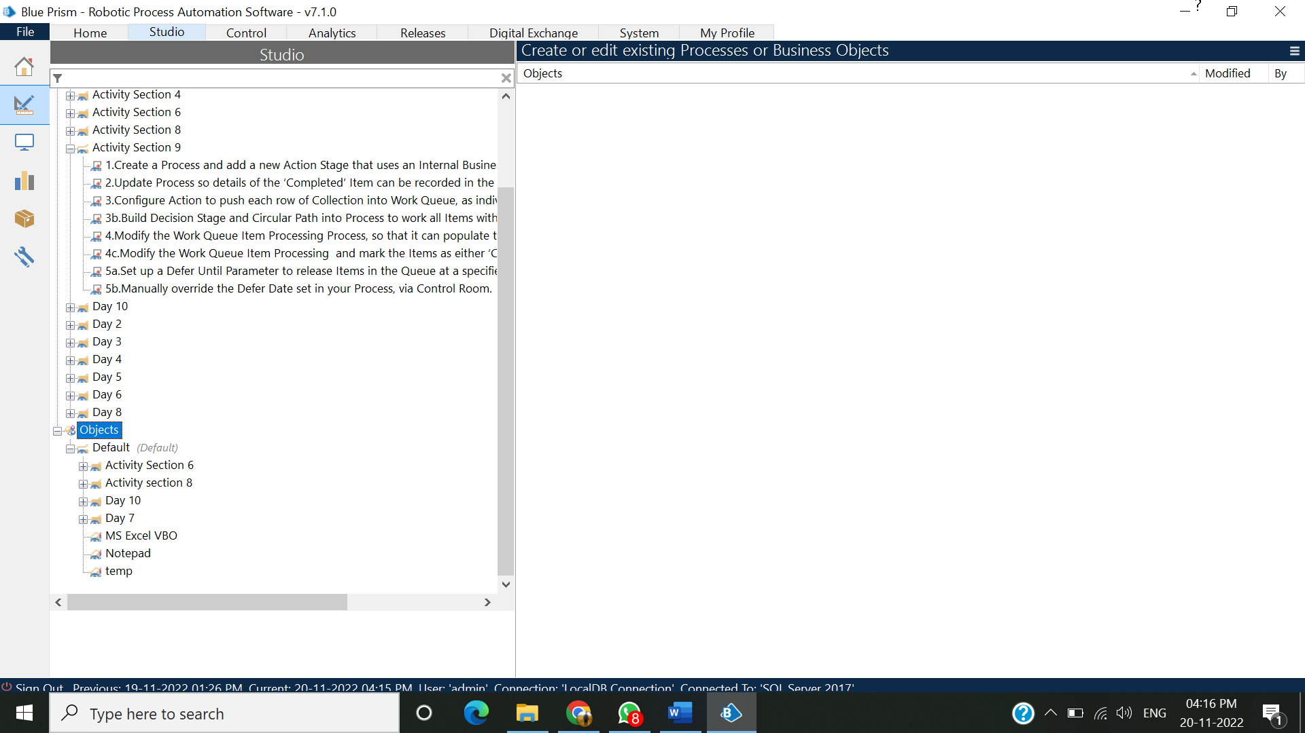

### Process Studio

Process Studio allows the company or IT to design, build, edit, and test processes made of reusable Blue Prism elements. As the library of business objects grows, actions can be scheduled and controlled in the process layer, the top tier of the Blue Prism architecture.

Process Studio provides a similar interface to Object Studio and allows you to sequence and test business logic, control loops, variables, and object calls in a visible business flow.

Processes in Blue Prism are comparable to software procedures in that they can invoke objects and operations to run applications, automate rules-based processes and business logic.

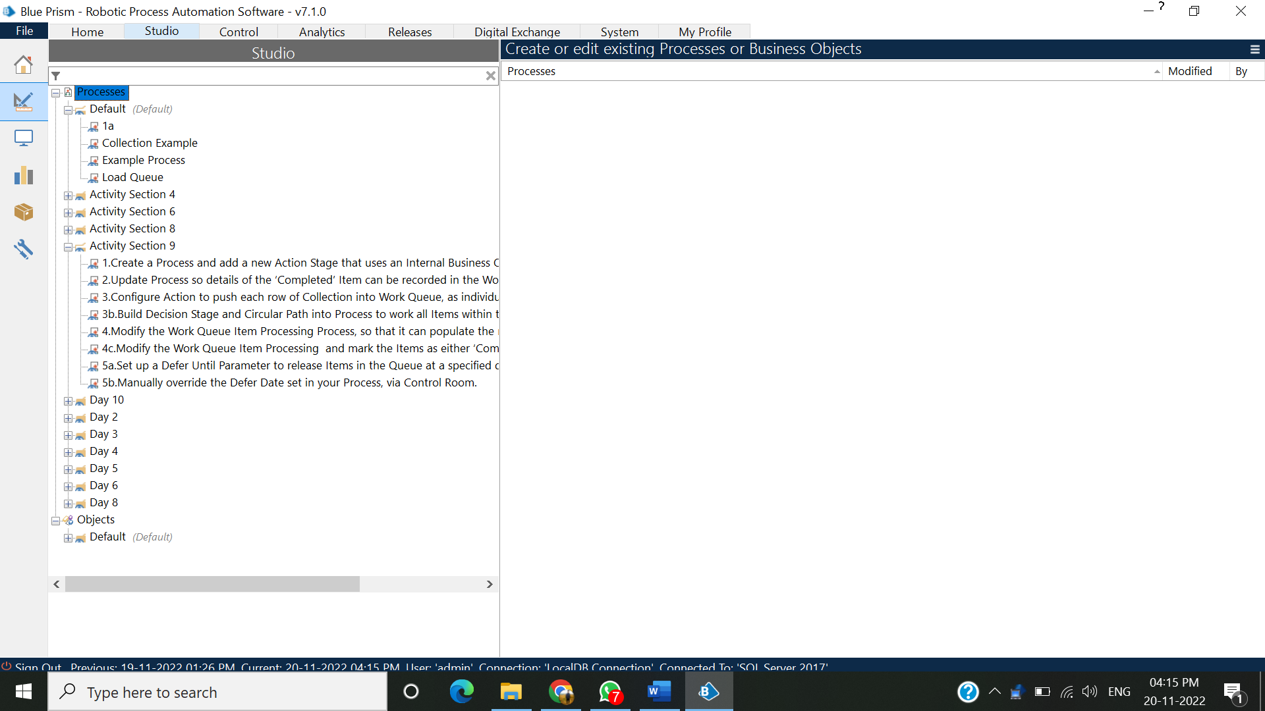

### Control room

Control Rooms allow businesses or IT services to schedule, perform, and control processes.

Blue Prism platform administrators can use the Blue Prism Control Room interface to monitor and review the status of the connected runtime resources in the production environment.

The interface also allows for manual process start and stop, automated process schedule setting, and extensive management information and dig downs into Blue Prism task queues.

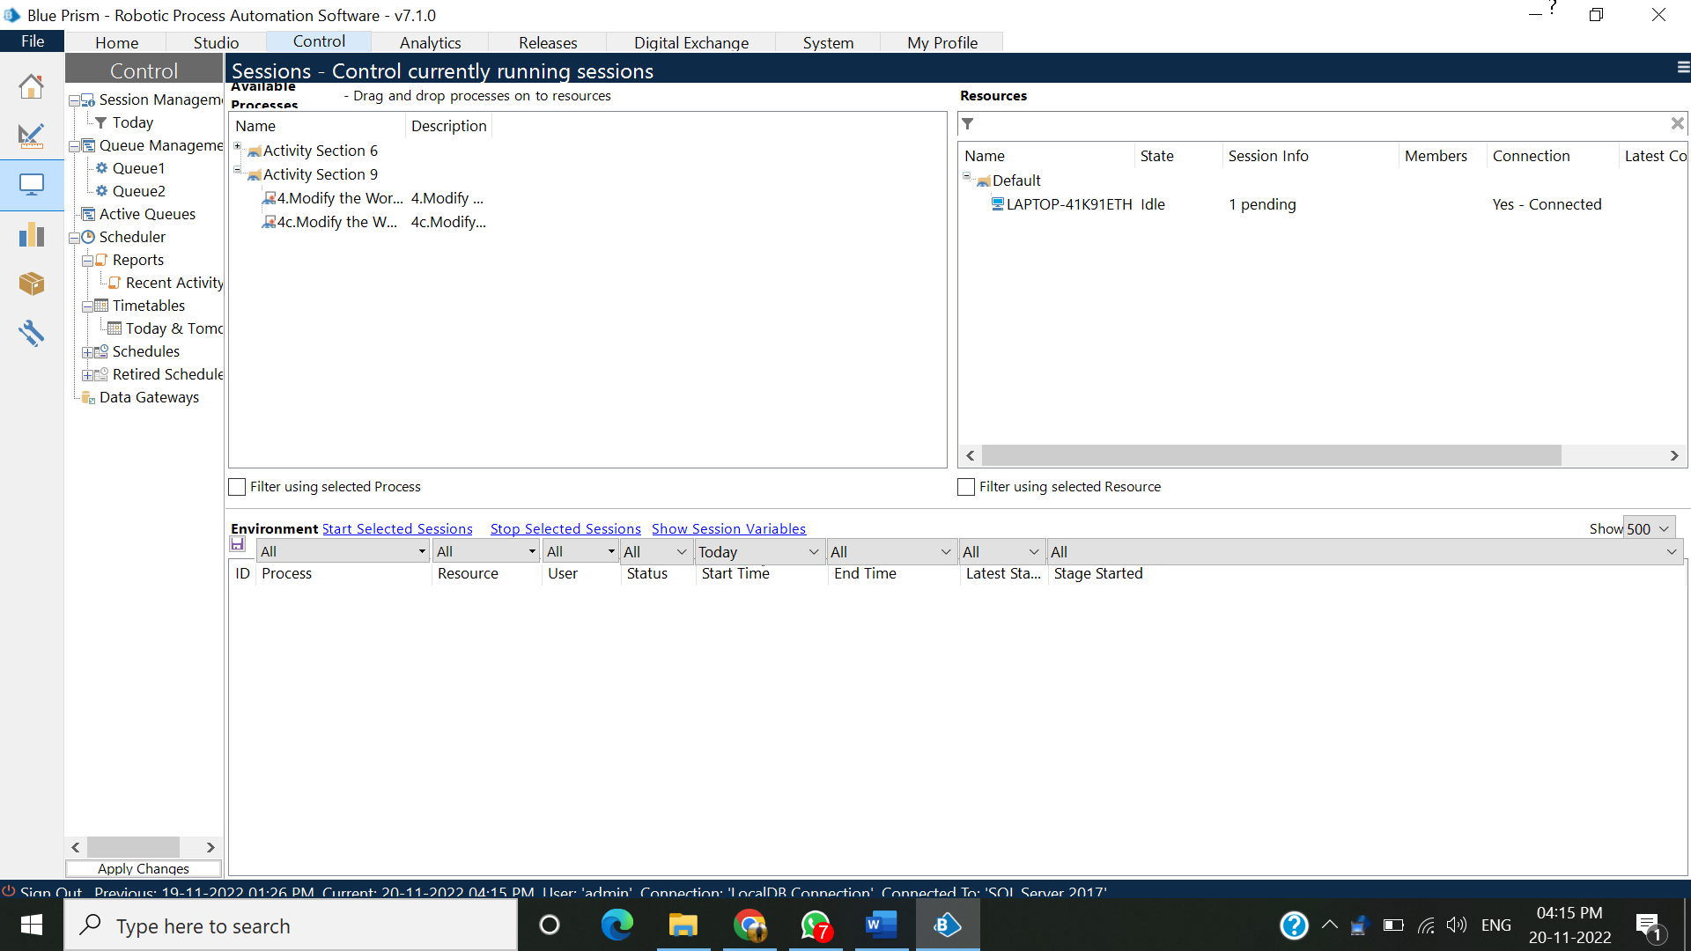

1. **Tools & Technology Used:**

Blue Prism is built on the [Microsoft .NET Framework](https://en.wikipedia.org/wiki/Microsoft_.NET_Framework). It automates any application and supports any platform ([mainframe](https://en.wikipedia.org/wiki/Mainframe), [Windows](https://en.wikipedia.org/wiki/Microsoft_Windows), [WPF](https://en.wikipedia.org/wiki/Windows_Presentation_Foundation), [Java](https://en.wikipedia.org/wiki/Java_(programming_language)), web, etc.) presented in a variety of ways (terminal emulator, thick client, thin client, web browser, Citrix and web services).

1. **Discussion**

**Analysis and Observations:**

We have learnt many things such as Project Studio, Object Studio, Data Types and Variables, Work Queues, Debugging, Credentials and Credential Manager in Blue Prism Training.

## Applications of Blue Prism

## 

Blue Prism’s RPA software is used in the following process types.

* Rules-based processing using structured digital inputs, such as credit card activation or fraud detection.
* Transactional processing that is repeated, such as SIM swaps or invoicing processing.
* High transaction quantities, such as billing or new handset order processing.
* Issues with process adherence/quality, such as policy renewals or policy migrations.
* Complex or mission-critical procedures such as pension redemptions and financial reconciliation.
* Changes in demand or backlogs, such as new product launches.
* Used in HR onboarding or introducing a new online product, where no integration exists.

## Benefits of Blue Prism

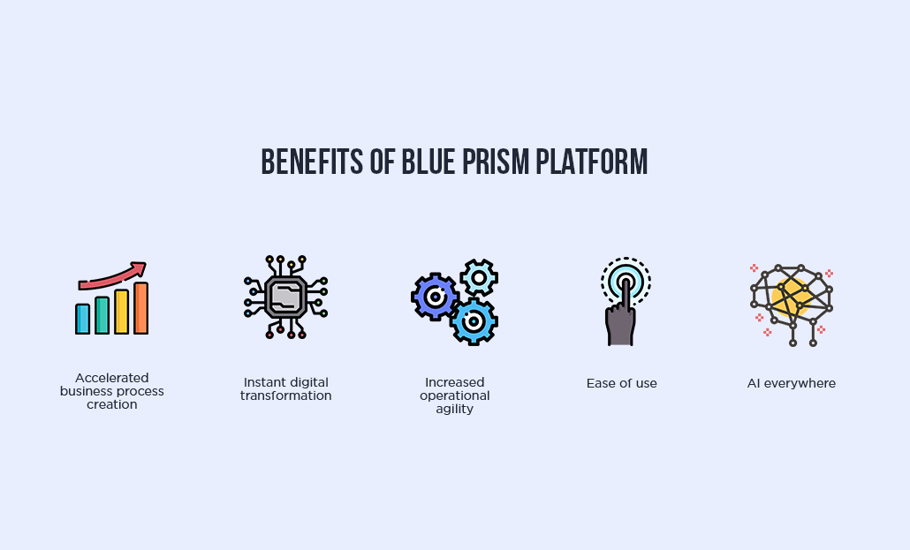

### Automation Speed

Days and weeks to automate processes in a Blue Prism would take months and years to automate using standard automation methodologies.

### Less Expense

Robots are programmed with the business rules of repetitive clerical duties and deployed to drive existing applications, eliminating the requirement for costly integration and process re-design expertise.

### Improved Performance

A small specialist ability within the IT department collaborates with the robotic workforce to train them, manage referrals, and continuously enhance the robots' operational performance.

### Secure

The robotic automation platform is secure, audited, and governed within the governance IT corridor. The usage of software robots invariably increases compliance with applicable data standards, confidentiality, and the speed and accuracy of record keeping.

### Scalable

Because the software robots operate in a virtualized environment, they can rapidly scale them up and down based on demand.

## Companies Using Blue Prism

Many top-tier organizations, such as Google, Accenture, EY, KPMG, Jaguar, Siemens, Microsoft, and IBM, use a Blue Prism.

1. **Conclusion**

Blue Prism RPA's main role is to reduce the time taken in functional processes. To improve efficiency in repeating operations and minimize errors. It is applied in varied processes which need precision and is sensitive to be handled by humans. RPA is useful for maintaining management systems and highly secured automation systems.

1. **References**

Website

<https://google.com/>

<https://www.blueprism.com/>

<https://www.wikipedia.org/>

**Books**

Blue Prism MasterClass: Developer & Professional Developer

Blue Prism Tips: Become an Advanced Blue Prism Developer